



+ Our Services +

EVENT PHOTOGRAPHY

WEDDING PLANNER

MOVIE MAKING & COVER SONG

BRING YOUR CREATIVITY TO LIFE

SIDPIC

PHOTOGRAPHY



A camera that put s a word of possibilities at your fingertips Literally.

About Us





I love, people in love, being in love, gestures of love, doing what you love. To live with a full heart is a wonderful thing.

A SidPic Photography Team are Discover the all types of Events, Photography, Wedding Planning, Wedding Decoration, Movie Making, and Cover Songs.

Deconstructing the client’s expectations and building the event step by step from there, is SidPic Studio Event India's main forte. SidPic Photography events specializes in is large enough to operate efficiently and effectively, yet small enough to create the event of your dreams with relentless pursuit of perfection nestled with undivided attention to every smallest detail.

Equally as much love photography and being able to photography the beautiful, the imperfect, the crazy and the grittiness of life for photography I like working with people, telling stories and creating character in my images.

While I am taking care of regional clients, I keep working on various National/International assignments while offering turnkey solutions to the clients anywhere in the world. Having achieved so much in such less time, I still feel that my journey has just begun.

Our aim is to provide a luxurious experience to our clients, making them feel on the top of the world.

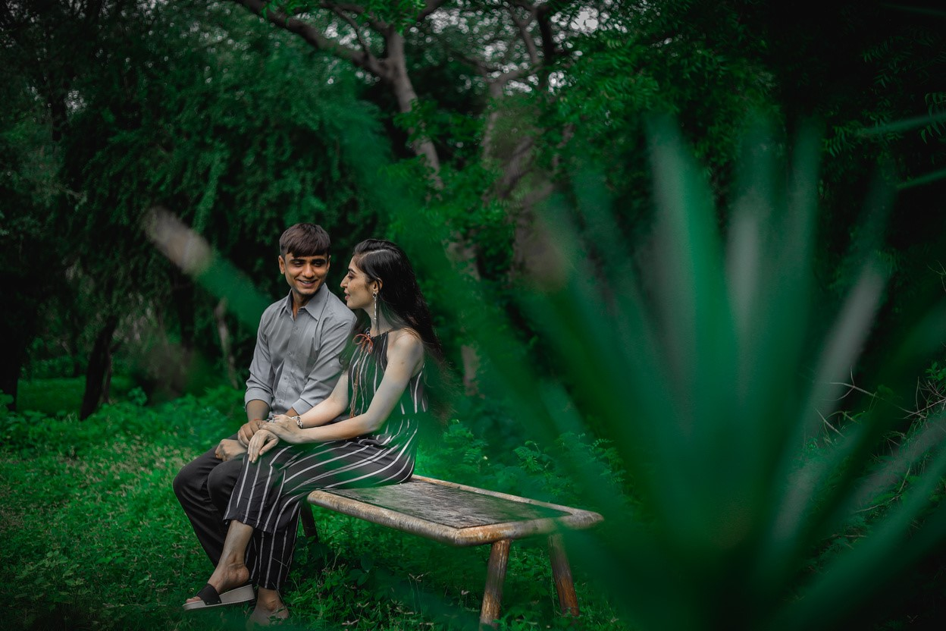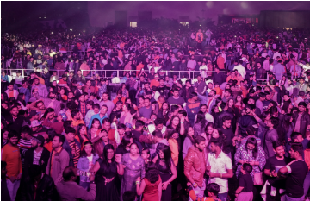

Events





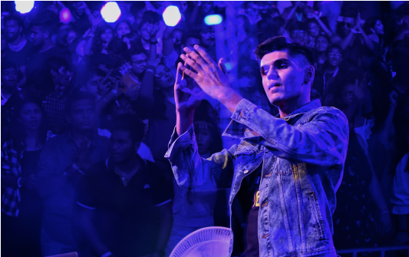





Events Vibes ……

As a wedding planner in India, we bring unique touches to weddings, focusing on executing your special day down to the last detail. This means that we take care of presenting you with only the most suitable venues and vendors according to your budget and taste. We at Marry Me work closely with you — the couple — and your families to plan a wedding that is uniquely yours and that is a reflection of your tastes. This means that whether you opt for a small and intimate wedding, a large-scale production, or even an exotic destination wedding, we will make your wedding day the most special and unique — one that will be remembered forever. We take pleasure in the fact that we have been able to create memorable moments by blending Indian tastes and tradition with contemporary touches

Terms & Conditions



* PAYMENT

THE CLIENT agrees that 50% deposit is required to book the wedding and 30% after the wedding not more than 3 days and of the remaining balance is due on delivery of the contracted deliverables

* ENTIRE AGREEMENT

This agreement contains the entire understanding between SidPic Photography.

WEDDING PHOTOGRAPHY and It supersedes all prior and simultaneous agreements between the parties. The only way to change or add to this agreement is to do so inwriting, and providing the document is signed by all the relevant parties

* RESERVATION:

Upon your signature SidPic Photography WEDDING PHOTOGRAPHY will reserve the time and date agreed upon, and will not make other reservations for that time and date. For this reason, the Reservation Deposit of 20% is non-refundable, even if the date is changed or the wedding cancelled for any reason; including acts of God, death, sickness, fire, strike and/or extreme weather. The Reservation Deposit is to be paid at time of signing the contract along with the first payment 50% of the contracted wedding photography. The Reservation Deposit is applied towards the contracted wedding photography package. The client/s: understands and agrees that the entire amount owed for the wedding photography package described in the contract is due on the date of delivery

* CANCELLATION:

In the event that the client/s cancels the contracted services for wedding photography outlined in this contract before the wedding ceremony takes place, the deposit will be forfeit. SidPic Photography WEDDING PHOTOGRAPHY agrees to refund all additional paid money (less expenditures for which receipts will be provided), to the client. CANCELLATION BY THE PHOTOGRAPHER: In the unlikely event that the SidPic Photography WEDDING PHOTOGRAPHY is forced to cancel the contract beyond control, liability is limited to a full refund of the payment made till date.

* EVENT GUIDE

The client will be responsible for (or have someone designated for this responsibility) identifying people/objects of whom/which specific photographs are desired. The photographer will NOT be held accountable for not photographing desired people if there is no one to assist in identifying or gathering people for the photograph(s).

* SHOOTING TIME / ADDITIONS:

The photography schedule and selected methodology are designed to accomplish the goals and wishes of the client in a manner enjoyed by all parties involved. The client/s and SidPic Studio WEDDING PHOTOGRAPHY agree that positive cooperation and punctuality are therefore essential. Shooting commences at the scheduled time. Should the ceremony start late due to any reason whatsoever, SidPic Photography will not be held liable for any photographs not taken. Extra shooting hours are chargeable as mentioned the contracted wedding photography package.

* DELIVERY

SidPic Photography WEDDING PHOTOGRAPHY will deliver the PD and any additional material that may have been ordered and paid for in addition to the original service. Minimum 4 weeks of time will be taken to deliver the contracted deliverables.

* Final edited Wedding Albums & Video is delivered minimum 8 Weeks after wedding
* CLIENT RESPONSIBILITY: THE CLIENT is responsible for making contact with CAPTURINGTM WEDDING PHOTOGRAPHY 14 days prior to wedding date.
* After 2nd Time There Is Extra Charges
* Limitations of Changes in Teaser is Only 2 Times
* After 2nd Time There Is Extra Charges
* No Extra Changes in 2hr Sequence Video
* SidPic Studio Provides You Teaser & Highlight in Between 2 Months after the Wedding
* Album Timing Depends Clients Photo selection Time-Album work has been done After 1 Month of

Authorized person

of SidPic Sign



Clint Sign





Wedding & Pre-Wedding details



Dear,

As Per Are Conversation. Here Is the Details of the Photography, Videography, & Cinematography Type of Shoot of Your Wedding Shoot. We Feel That Should Be Kept to Cover the Whole Wedding Event in Very Nice Manner.

**Silver pack**

* Day 1 photo Video (DSLR)
* Day 2 photo (DSLR) video candid

**Things we provide**

1 Wedding Teaser

1 Wedding Highlight

1 Wedding Short Film (10 t0 15 Min)

1 Opset Album (12*36 worth Photo Of 300

All Raw Photos in Pen Drive

1 Invitation Video

**\*Cost Of Pack\***

**65,000/-**

Clint Sign



**Terms & Conditions**

**Click Here**



Wedding & Pre-Wedding details



Dear,

As Per Are Conversation. Here Is the Details of the Photography, Videography, & Cinematography Type of Shoot of Your Wedding Shoot. We Feel That Should Be Kept to Cover the Whole Wedding Event in Very Nice Manner.

**Gold pack**

* Day 1 photo, Video (DSLR), candid
* Day 2 photo (DSLR), video, cine, candid

**Things we provide**

1 Wedding Teaser

1 Wedding Highlight

1 Wedding Short Film (10 t0 15 Min)

1 Opset Album (12*36 worth Photo Of 300

1 couple Album Worth Photo Of 50 to 70)

All Raw Photos in Pen Drive

1 Invitation Video

**\*Cost Of Pack\***

**90,000/-**

Clint Sign



**Terms & Conditions**

**Click Here**



Wedding & Pre-Wedding details



Dear,

As Per Are Conversation. Here Is the Details of the Photography, Videography, & Cinematography Type of Shoot of Your Wedding Shoot. We Feel That Should Be Kept to Cover the Whole Wedding Event in Very Nice Manner.

**Platinum pack**

* Day 1 photo, Video (DSLR), cine, candid
* Day 2 photo (DSLR), video, cine, candid, drone

**Things we provide**

1 Wedding Teaser

1 Wedding Highlight

1 Wedding Short Film (10 t0 15 Min)

1 Opset Album (12*36 worth Photo Of 300

1 couple Album Worth Photo Of 50 to 70)

All Raw Photos in Pen Drive

1 Invitation Video

**\*Cost Of Pack\***

**1,10,000/-**

Clint Sign



**Terms & Conditions**

**Click Here**

**Terms & Conditions**

**Click Here**



Wedding & Pre-Wedding details



Dear,

As Per Are Conversation. Here Is the Details of the Photography, Videography, & Cinematography Type of Shoot of Your Wedding Shoot. We Feel That Should Be Kept to Cover the Whole Wedding Event in Very Nice Manner.

**Me pack**

Photo, Video, Candid, Cine, Drone

**Things we provide**

1 Teaser

1 Highlight

10 Photos Days to Go

1 Photo Save The Date

20 Photos Edited (Colour Correction & Softening)

**\*Cost Of Pack\***

**40 to 50,000/-**

Clint Sign



**Terms & Conditions**

**Click Here**



Special Package from SidPic Photography



Dear,

If You Provide Us Order from Both Side (Bride & Groom) & Pre-Wedding Also We Will Provide Same Quality to Both sides.

**Me pack**

Photo (DSLR): 7000/-

Video: 7000/-

Cine: 15,000/-

Candid: 9,000/-

Drone (Only in marriage day): 5000/-

**Things we provide**

1 Wedding Highlight, 1 Wedding Short Film (10 t0 15 Min), 1 Opset Album (12*36 worth Photo Of 300 1 couple Album Worth Photo Of 50 to 70), All Raw Photos in Pen Drive, 1 Invitation Video, 1 Teaser, 1 Highlight, 10 Photos Days to Go, 1 Photo Save The Date, 20 Photos Edited (Colour Correction & Softening)

**\*Cost Of Pack\***

**1,90,000/-**

**Package include wedding from both side and pre-wedding**

Clint Sign



**Terms & Conditions**

**Click Here**

**Terms & Conditions**

**Click Here**



All Packs

Terms & Conditions



50% Advance 50% On Wedding Day

Limitations Of Changes in Highlights Is Only 2 Times After 2nd Time There Is Extra Charge

Limitations Of Changes in Teaser Is Only 2 Times After 2nd Time There Is Extra Charges

No Extra Changes Will Allow in Short Film

SidPic Photography Will Provide You Teaser & Highlight between 2 Months After Wedding

Album Timing Depends Clients Photos Selection Time

Album Work Has Been Done After 1 Month of Photo Selection Time by Client

Team Work



The Team SidPic Studio- The Total crew will be an around 4 peoples in a day of any function.

They all are Professional & Esperance Persons (Creative Videographers, & Expert Photographers)

Capturing weddings” Photography is a team of enthusiastic artists in Ahmedabad. we every spark of your joy in digital form. Our cameras freeze your unscripted moments, bringing out the Wedding highlights and making an impression more beautiful than reality.

Pre-Wedding Details



One Cover Album Song

1min Special teaser of the pre wedding song will be designed

pre wedding Photo slide show

SidPic Studio’s 5 Assurance



1. Trusted

SidPic Photography, is the most trusted & the single largest wedding photography service provider. It has successfully completed 230 weddings and still counting.

2. Professional

Professional photographer & videographer to capture your happy moments on your special day.

4. Easy Selection

Now, you can select photos with ease through for Soft Copies and OTG pen drive.

3. Creative

We have creative and qualified in house design team, who can create memorable video and photo album.

5. Timely Delivery

Assured fast delivery of printed album and videos within 20 days (after Photo Selection). You also get high-definition printable e-album for future use.







Contact Now:



+91 9724901396, +91 9998778568

Email: Dudessstudio@gmail.com

@SidPic_Photography



+ Our Services +

EVENT PHOTOGRAPHY

WEDDING PLANNER

MOVIE MAKING & COVER SONG